Camunda 8 - Getting Started with Microservice Orchestration

Business Requirement
We will be using a fictitious organization; Camundanzia, as the scenario for this course.

Camundanzia
Scenario
The Camundanzia insurance company would like to introduce process automation throughout their organization. The first process they would like to automate is their Payment process.
Camundanzia has developed an eCommerce website (Webshop) which allows insurance partners to order Camundanzia branded products such as pens, notepads and water bottles for marketing events. Camundanzia partners must purchase these items using a credit card.
Partner purchases made using a credit card are processed automatically without the need for approval by an Accountant.

User Story
Two simple User Stories to capture Camundanzia's requirements can be found below:
User Story
- As an Accountant
- I want all Partner purchases to be made using a credit card
- So that all purchases can be made without human intervention
User Story
- As a Partner
- I want to purchase Camundanzia goods using a credit card
- So that I have an efficient purchasing experience

Acceptance Criteria
We will take an MVP approach to developing an application that meets these requirements.
The initial acceptance criteria that we will be working to are:
- Partner orders are processed using the Payment Process
- The Payment Process requires a Payment Request which includes the Reference, Amount and Credit Card Details
- The Payment Process processes orders automatically using a Credit Card Service i.e. without human intervention

Iterative Development
Iterative Development
Camunda is well suited to an iterative development approach; applications can be easily revised and upgraded without affecting in-flight processes.

Outline Solution
We now have a clear set of requirements and acceptance criteria for the Camundanzia webshop Payment Process.
The sections below will provide you with an overview of how to develop a Microservice Orchestration solution that meets these requirements.

Camundanzia
Scenario
Imagine that you have recently joined Camundanzia as a new Developer and have been assigned to the Camunda project team. Your first assignment is to implement the Payment Process using the requirements from the previous lesson.
Fortunately for you, a more experienced Camunda Developer has drafted an outline solution for you. Your task is to implement a solution based upon the outline that has been provided.

Outline Solution
The more experienced Developer has provided an overview of the work that must be completed for each of the stated acceptance criteria Both the configuration that you, the Developer, must carry out and the Camunda components that provide the necessary capabilities are covered by this.

Process Order using Payment Process
The core of the solution is provided by being able to execute a Process Instance in Camunda. In order to execute a Process Instance we need to create a Process Definition which models the business process.
- Process Definitions are created using the 🔗Modeler
- Process Instances are executed using the 🔗Zeebe Engine
- Process Instances can be monitored using 🔗Operate
Create Process Definition
Create a Process Definition that represents the Payment Process.

Create Charge Credit Card Task
Create a Task which will be used to request payment from the Credit Card Service.

Call the Credit Card Service
The Credit Card Service should be called from the Payment Process once it reaches the Charge Credit Card task. This can be achieved in Camunda by creating a Job Worker which calls the Credit Card Service.
Create a Job Worker
Create a Job Worker which calls the Credit Card Service to make a payment.

Create Payment Request
The Credit Card Service requires a Payment Request in order to automatically process the transaction.
Create a Client
Create a Client that starts the Payment Process with a Payment Request (Reference, Amount & Credit Card Details)

Handle Process Data
Handle the Process Data that has been provided to the Process Instance so that the Credit Card Service processes the payment correctly and without human intervention

Development Plan
Now that we have identified the components and features of Camunda which will be used to implement our solution, we can create a plan of the work that needs to be performed and the tools that will be required.
- Create a Process Definition
  - This will be configured using the Desktop Modeler
- Deploy the Process Definition
  - This will be performed from the Desktop Modeler
- Create a Job Worker
  - This will be performed from your preferred IDE e.g. Eclipse, IntelliJ
- Test the Process
  - This will be performed from your preferred IDE, Desktop Modeler and Operate
Create Client Credentials
We now need to create a set of Client Credentials so that we can access our Cluster.
Client Credentials
In order to interact with the Zeebe Engine in the cloud, every client application must authenticate itself. Authentication against Zeebe is managed using an OAuth flow.

Create Client Credentials
Existing Client Credentials
This section can be skipped if you already have created a set of Client Credentials for your Cluster in Camunda SaaS
Follow the steps below to create a set of Client Credentials for your Cluster:
- Navigate to Clusters from the top menu of the Camunda Console.
- Click on the Camundanzia cluster from the list that appears
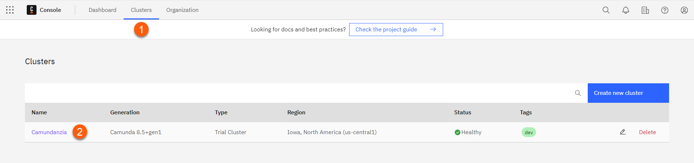
- Click on the API tab from the Cluster Details page
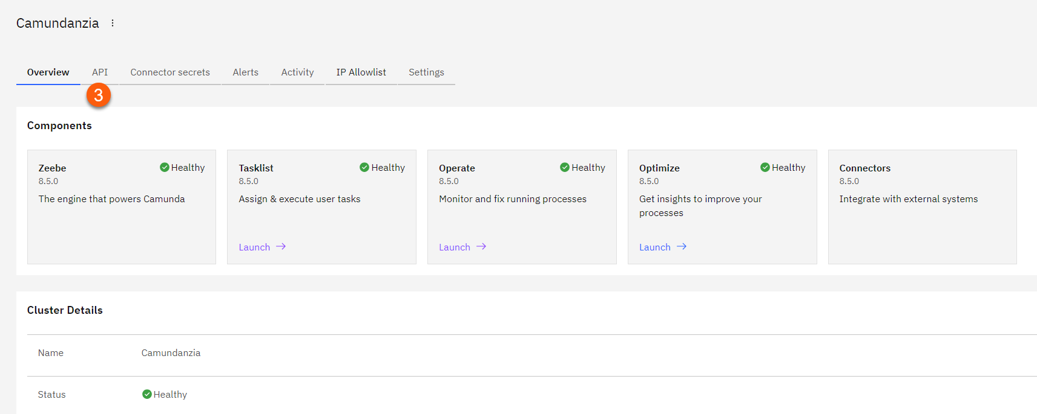
- Click on the Create your first Client button to launch the Create New Client Credentials dialog box
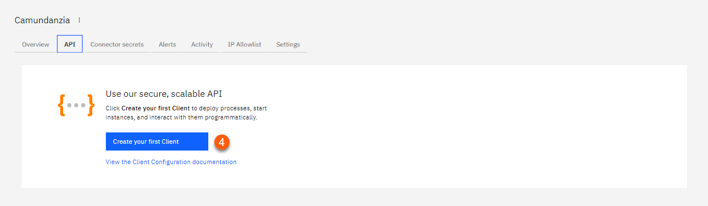
- Type a Name for the Client Credentials. For this course we will be using Camundanzia.
- Select an appropriate Scope for the Client Credentials. For this course we will be using Zeebe
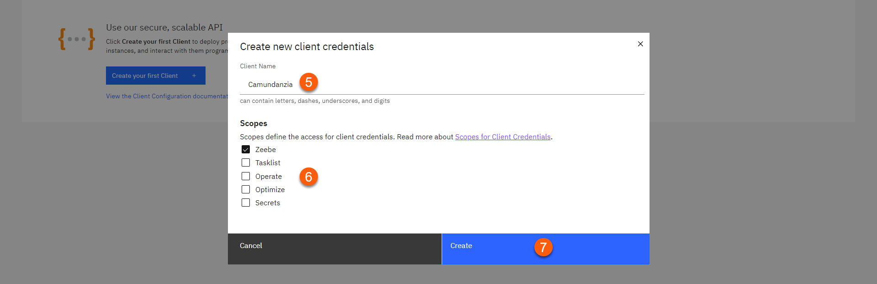
What is a Scope?
The Scope for Client Credentials limits the level of access that is available with those credentials. For Camunda, the available scopes control access to the following:
  - Zeebe - Access to the Zeebe gRPC API
  - Tasklist - Access to the Tasklist GraphQL API
  - Operate - Access to the Operate REST API
  - Optimize - Access to the Optimize REST API
  - Secrets - Access cluster secrets in a hybrid setup
Using connectors?
Connector Runtime expects valid credentials for Zeebe and Operate according to the connector type:
  - Outbound connectors require only one Scope: Zeebe.
  - Inbound connectors require two Scopes: Zeebe and Operate
Principle of Least Privilege
When creating Client Credentials you should try to follow the Principle of Least Privilege i.e. clients should only have access to the minimum scope required to perform their function.
- Click Create to create the Client Credentials
- A dialog box will be displayed containing both the Spring Boot and Environment Variable version of your Client Credentials
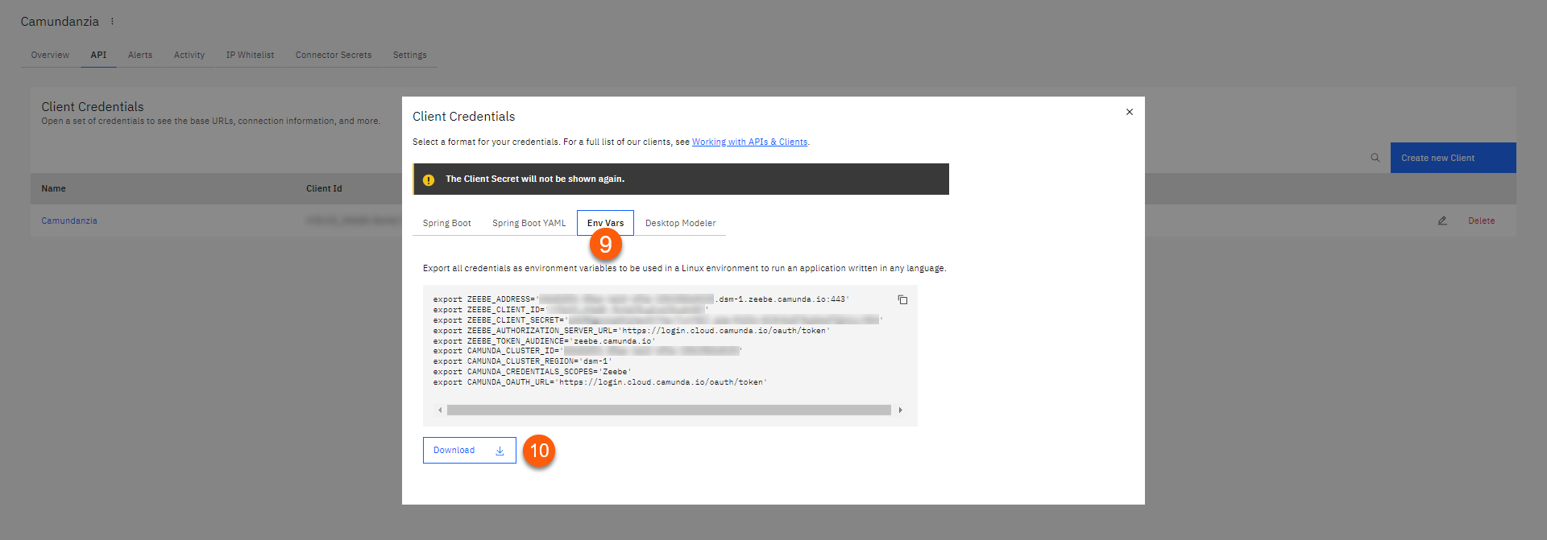
Spring Boot
Clicking the Spring Boot tab will allow you to download the credentials as an application.properties file that can be easily used with the Spring Boot Zeebe Client.
- Click the Environment Variables tab
- Click the Download button
- A file named CamundaCloudMgmtAPI-Client-<<Client Credentials Name>>.txt will be downloaded to your local Downloads folder. This file contains the following properties which are required to connect to your Cluster.
export ZEEBE_ADDRESS='**********.zeebe.camunda.io:443'export ZEEBE_CLIENT_ID='**********'export ZEEBE_CLIENT_SECRET='**********'export ZEEBE_AUTHORIZATION_SERVER_URL='https://login.cloud.camunda.io/oauth/token'export ZEEBE_TOKEN_AUDIENCE='zeebe.camunda.io'export CAMUNDA_CLUSTER_ID='**********'export CAMUNDA_CLUSTER_REGION='bru-2'export CAMUNDA_CREDENTIALS_SCOPES='Zeebe'export CAMUNDA_OAUTH_URL='https://login.cloud.camunda.io/oauth/token'
Save Credentials
Remember to save your credentials before closing the dialog box. You will need to generate new credentials if you forgot to save them at this point.
- Your new Client Credentials will be displayed under the API tab once you close the dialog box

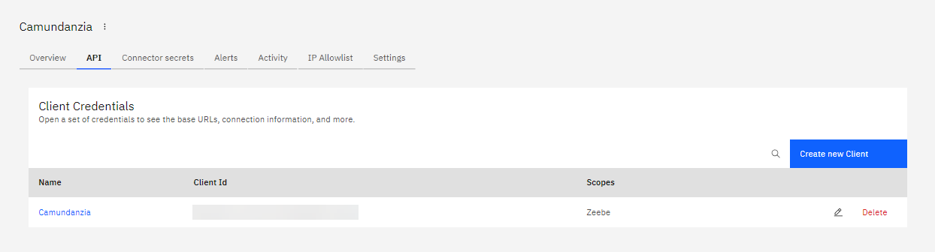
Created Client Credentials
Congratulations! You have now created a set of Client Credentials which can be used to access our Cluster.
Create Process
We will now create a new Process Definition (BPMN Diagram) which will be used to model the Payment Process.
Payment Process
The Payment Process is one part of the Order Process which will be started whenever a Partner places an order from the webshop. The Order Process orchestrates all of the tasks which need to be completed to fulfil the order.
The Order Process contains an activity to invoke the Payment Process which is the focus of this course.
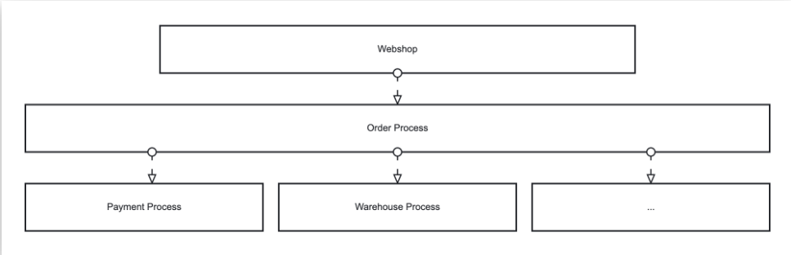

Create Process Definition
Create a new Process Definition by following the steps below:
- Launch the Desktop Modeler
- Create a new Camunda 8 BPMN Diagram by clicking the button on the Modeler launch page
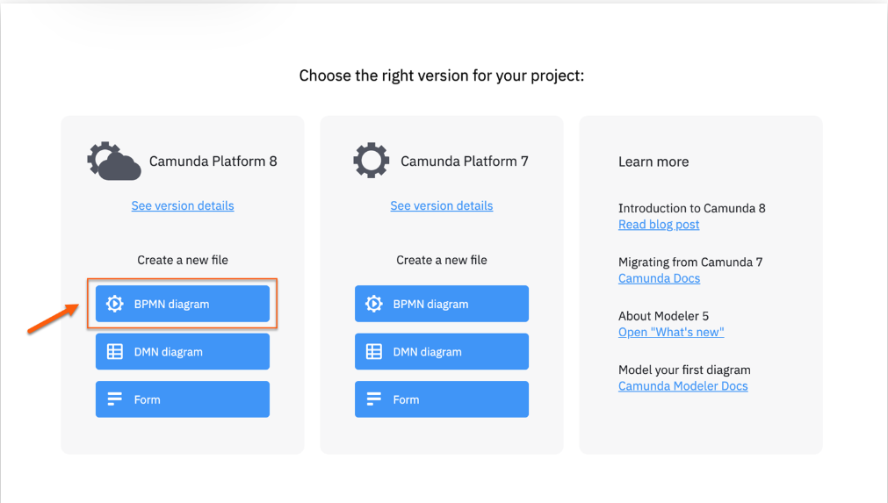

- This will open a new BPMN Diagram in the Modeler. In the properties panel on the right-hand side of the screen, set the Name and ID as follows:
Name | Value
Name | Payment process
ID | paymentProcess
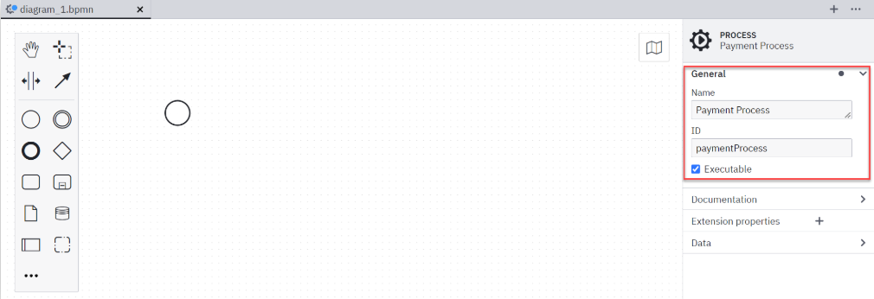

Naming Conventions for BPMN IDs
Define developer-friendly and business-relevant IDs for the process itself, as well as all activities, messages, and errors. Also consider events, gateways, and the sequence flows that carry conditional expressions. Even though IDs are just identifiers, keep in mind that they will show up regularly on the technical level. Meaningful IDs will help a lot.

Model Business Process

Add Start and End Events
All Process Definitions require at least one Start Event and at least one End Event
- Click on the Start Event in the process and then expand the General tab in the properties panel on the right-hand side of the screen. Set the Name and ID as follows:
Name | Value
Name | Payment Required
ID | StartEvent_PaymentRequired
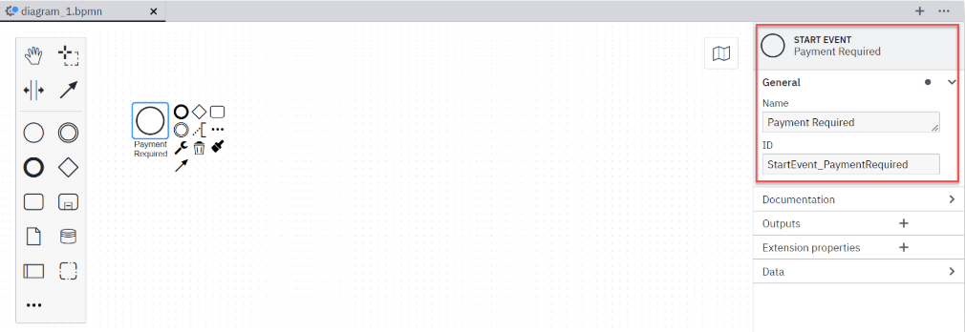
- Click on the End Event from the BPMN Palette to add a new element to the diagram.
- Click on the right-hand side of the diagram to place the End Event
- Set the Name and ID for the End Event as follows:
Name | Value
Name | Payment Done
ID | EndEvent_PaymentDone
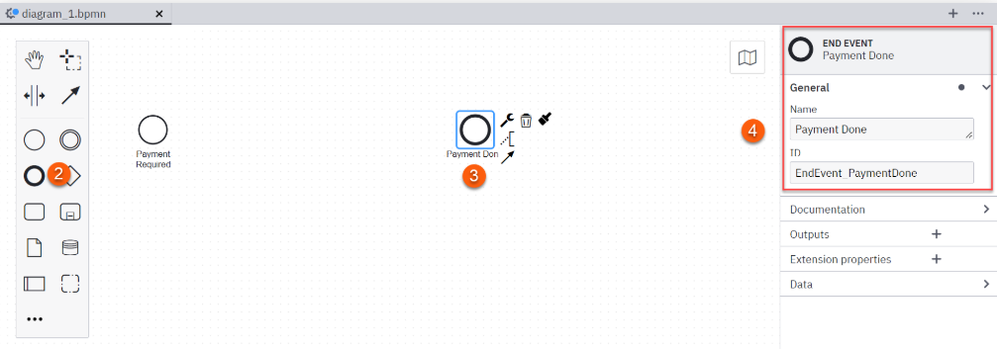
Naming Events
Wherever possible, name an event using an object and a verb reflecting a state. Always try to describe which state an object is in when the process is about to leave the event.

- Connect both events by activating the Global Connect Tool in the pallet and dragging a Sequence Flow from the Start Event to the End Event
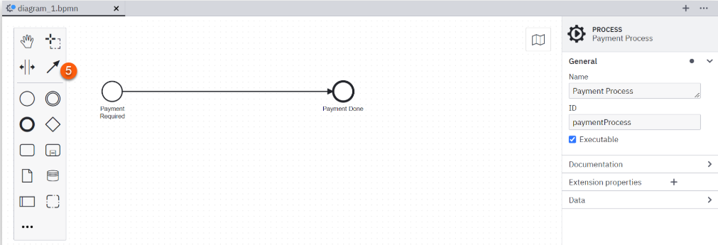

Add a Task
For the first draft of our process, we will create a single Service Task
- Click on the Task from the BPMN Palette to add a new element to the diagram
- Click the middle of the previously created Sequence Flow to place the Task on the diagram
- Click on the Change Type (Wrench) icon in the toolbox and then select Service Task from the context menu that appears
- Set the Name, ID and Type for the Service Task as follows:
Name | Value
Name | Charge Credit Card
ID | Task_ChargeCreditCard
Type | chargeCreditCard
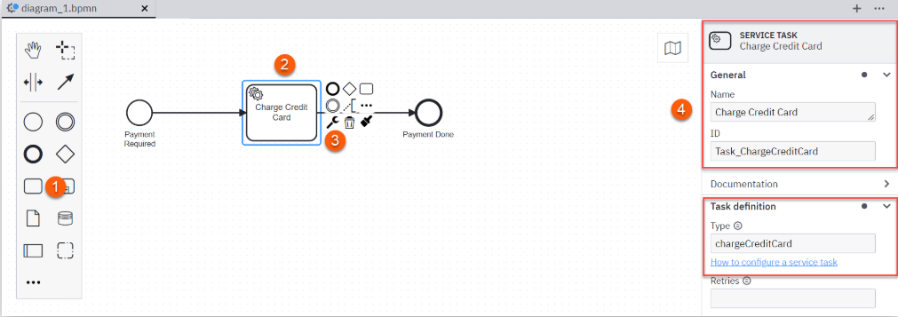
What is a Task Definition
A Service Task must have a Task Definition; the Task Definition defines which Job Workers can execute the Task.
When a Service Task is encountered in a Process Instance, a corresponding Job is created. The Process Instance stops here and waits until the Job has been completed.
A Job Worker can subscribe to a Job Type, process the Job and complete them using one of the Zeebe Clients. Once the Job is complete, the Service Task is complete and the Process Instance continues.

Arrange Diagram
Finally, we can arrange the diagram using the Create / Remove Space Tool.
- Click on the Create / Remove Space Tool in the BPMN Palette on the left-hand side of the screen
- Use the tool to evenly space the BPMN elements on the diagram. Your diagram should look similar to the one below when you have finished
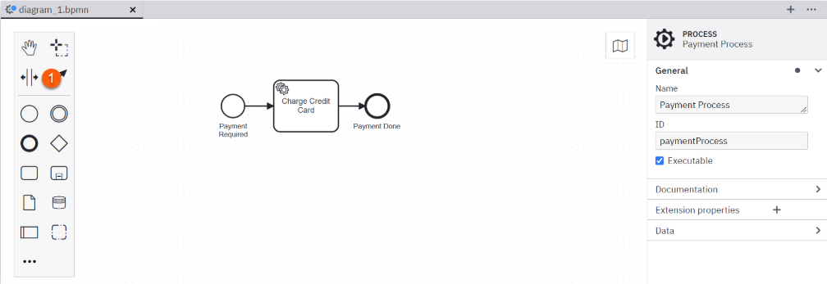

Readable Diagrams
We create visual process models to better understand, discuss, and remember processes. Hence, it is crucial that models are easy to read and understand.
- Click File -> Save File from the top menu to save your process diagram in a folder of your choice
- Name it as paymentProcess.bpmn.

Created a Process Definition
Congratulations! You have now created a Process Definition which captures the Payment Process.

Deploy Process
We will now need to deploy our Process Definition to the previously created Cluster so that we can start a Process Instance.
What is a Deployment?
A Deployment allows the Process Definition to be executed by the Zeebe Engine.

Deploy Process Definition
- Click the Deploy Current Diagram button from the Status Bar of the Camunda Modeler
- This will open a Deploy Diagram dialog box which should be populated using the values below. The ZEEBE_ environment variables can be obtained from the CamundaCloudMgmtAPI-Client-Camundanzia.txt which you downloaded in an earlier lesson
Name | Value
Deployment Name | paymentProcess
Target | Camunda 8 SaaS
Cluster URL | ZEEBE_ADDRESS
Client ID | ZEEBE_CLIENT_ID
Client Secret | ZEEBE_CLIENT_SECRET
- Click the Deploy button to deploy your process model to your Cluster
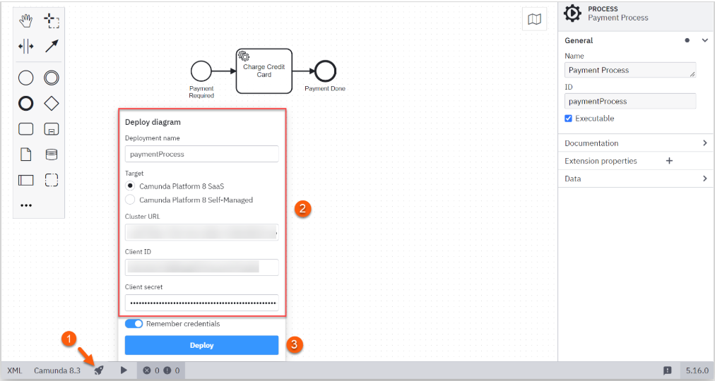

- You should see a Deployment Succeeded message if everything has been configured correctly
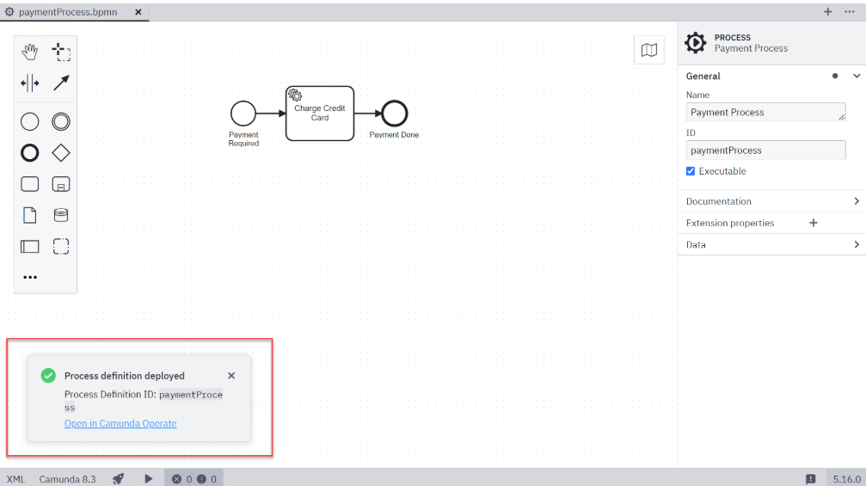
Deployment Error
Check that you have populated the correct values from your Client Credentials if you receive an error message instead of a success message.

View the Deployment in Operate
Next, we can take a look into Operate to confirm that the deployment has been successful.
What is a Deployment?
Operate is a tool for monitoring and troubleshooting process instances running in the Zeebe Engine.
In addition to providing visibility into active and completed process instances, Operate also makes it possible to carry out key operations such as resolving incidents, and updating process instance variables.

Launch Operate
Launch Operate by following the steps below:
- From the Console, select Clusters
- Select Camundanzia from the Clusters page
- Click the Launch link next to Operate in the Cluster Details page
- After a few seconds, the Operate Dashboard will be displayed
- You will also be able to see that the Payment Process is visible in the Dashboard
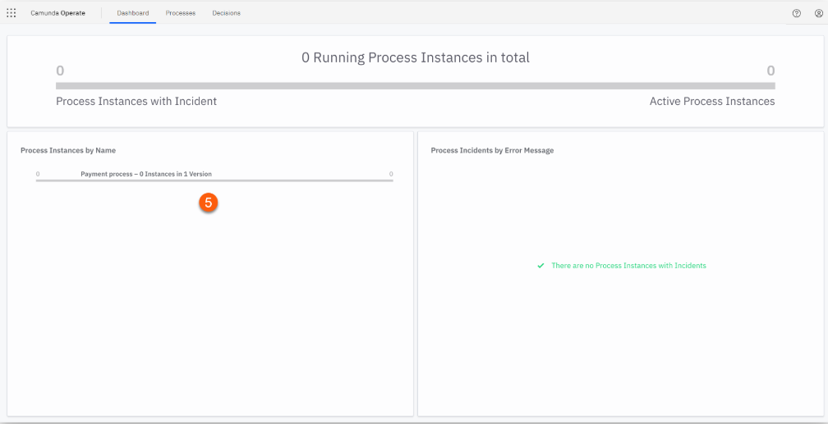

View Process Instances
We can now view the process instances in Operate by following the steps below:
What is a Process Instance?
One execution of a Process Definition is called a Process Instance. Many Process Instances can be launched from one Process Definition.

- Click on Payment Process from the Instances by Process panel on the left-hand side of the screen
- Operate will not show any active process instances at this point. However, we can see that version 1 of our Payment process has been successfully deployed
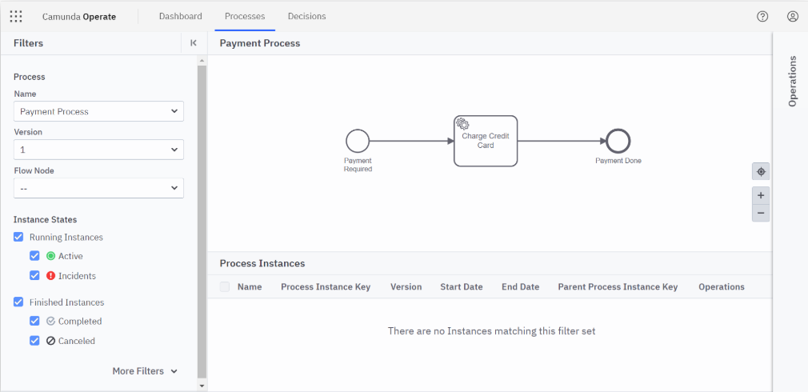

Deployed a Process Definition
Congratulations! You have now deployed the Payment Process Process Definition into the Zeebe Engine.

Start Process

We will now need to execute our Process Definition for the first time; this is also known as starting a Process Instance.

Start a Process Instance
Start an instance of the Payment Process by following the steps below:
- Select the Start Current Diagram button in the Status Bar of the Modeler
- This will open a Start Process Instance dialog box
- Click on the Start button without making any changes to the Variables section
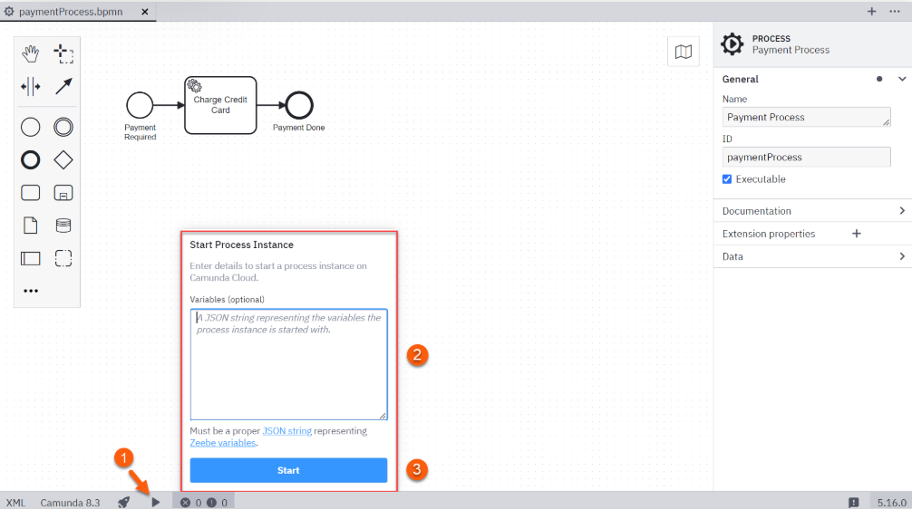

- You should get a Process instance started message
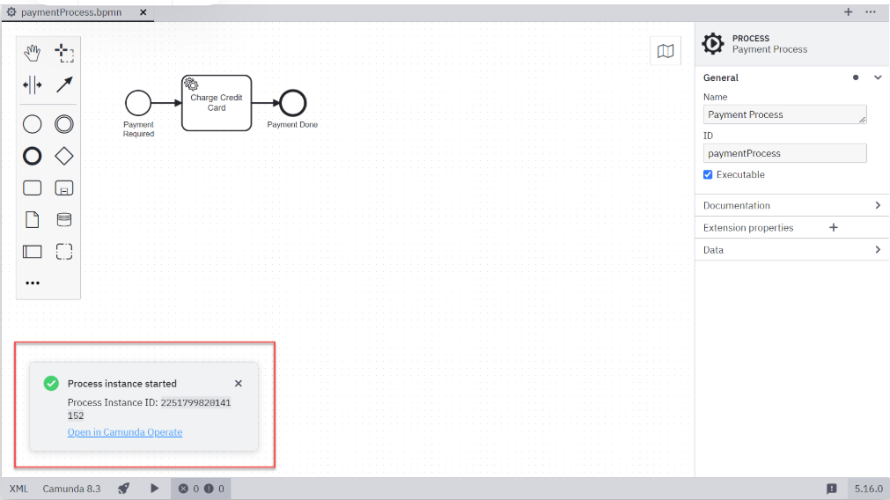

View Process Instances
We can now view the process instances in Operate by following the steps below:
- Launch Operate by following the steps in the previous lesson. Alternatively, refresh the window if you still have Operate open
- Click on Payment Process from the Instances by Process panel on the left-hand side of the screen
- Operate will now show a running instance of our Payment Process. The completion of the Charge Credit Card Service Task is still pending; you can see this from the presence of the green marker against the Service Task
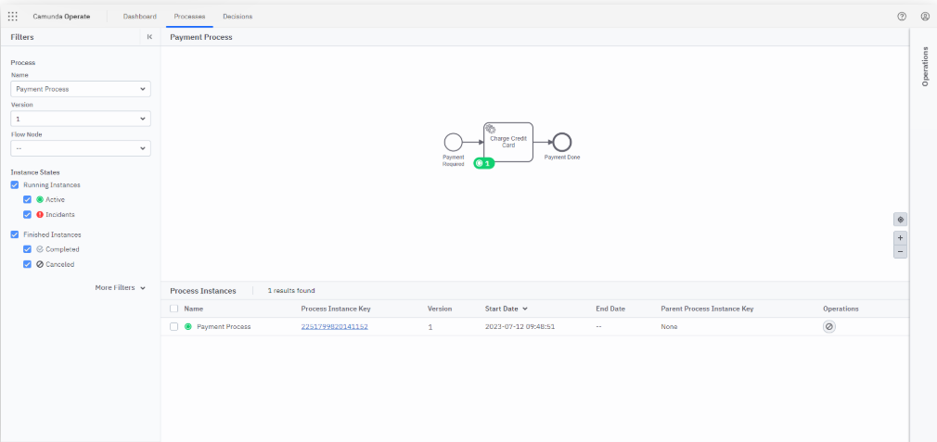

Started a Process Instance
Congratulations! You have now started an instance of the Payment Process.

Create Job Worker
We will now create a Job Worker which will be used to perform the Charge Credit Card task in the process that we have modeled.
What is a Job Worker?
A Job Worker is a service capable of performing a particular task in a process. Job Workers are used to manage the interactions between the Zeebe Engine and the outside world.
In this course we will be orchestrating a Credit Card Service from the Payment Process. The Payment Process is represented by a Process Definition and is executed as a Process Instance by Zeebe. The Credit Card Service is external to Zeebe and could be hosted anywhere; it is the Job Worker that connects the Credit Card Service to the Payment Process.

Payment Application
For this course, we will develop a Payment Application which will contain the following elements:
- Zeebe Client - The Zeebe Client allows you to interact with Zeebe using the API
- Job Worker - The Job Worker is responsible for requesting Jobs of a defined type from the Zeebe Engine
- Job Handler - The Job Handler is responsible for performing the actions required to complete a Job when it has been acquired by the Job Worker
- Credit Card Service - This is a simple, mock representation of a Credit Card Service
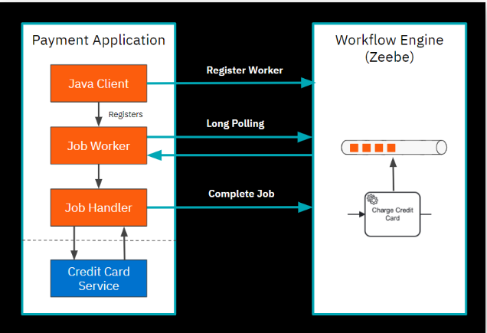

Zeebe Clients
Zeebe Clients allow applications to perform the following:
- Deploy a Process Definition
- Start and Cancel a Process Instance
- Activate Jobs and Complete Jobs
- Update Process Variables
Camunda provides several official clients for interacting with the Zeebe API. In this course we will be using the Java Client to create the Payment Application.

Create Client (Java)
As we will be using Java to develop our Job Worker, we will start by creating a new Maven project.

Create a Maven Project
Create a new Maven project by following the steps below (Command Line or IDE):
Create Maven Project using the Command Line
- Start a Command Prompt e.g. Terminal or PowerShell
- Change to an appropriate directory e.g. your IDE workspace
- Create a Maven Project using the following command
mvn archetype:generate \
-DgroupId=com.camunda.academy \
-DartifactId=c8-getting-started-microservice-orchestration-lab \
-DarchetypeArtifactId=maven-archetype-quickstart \
-DarchetypeVersion=1.4 \
-DinteractiveMode=false

- Maven will generate the new project and will output something similar to the following if everything has been successful
[INFO] Project created from Archetype in dir: C:\DevTools\Workspace\eclipse\camunda-academy\c8-getting-started-microservice-orchestration-lab
[INFO] ------------------------------------------------------------------------
[INFO] BUILD SUCCESS
[INFO] ------------------------------------------------------------------------
[INFO] Total time: 3.457 s
[INFO] Finished at: 2022-12-09T14:44:55Z
[INFO] ------------------------------------------------------------------------

- Change to the newly created project using cd c8-getting-started-microservice-orchestration-lab
- Confirm that the project can be built using mvn clean package

[INFO] ------------------------------------------------------------------------
[INFO] BUILD SUCCESS
[INFO] ------------------------------------------------------------------------
[INFO] Total time: 2.926 s
[INFO] Finished at: 2022-12-09T14:54:20Z
[INFO] ------------------------------------------------------------------------

Create Maven Project using an IDE
- Start your preferred IDE e.g. Eclipse or IntelliJ
- Create a new Maven project with the following properties
Name | Value
groupId | com.camunda.academy
artifactId | c8-getting-started-microservice-orchestration-lab
archetypeArtifactId | maven-archetype-quickstart
archetypeVersion | 1.4
version | 1.0-SNAPSHOT
- Confirm that the project can be built using mvn clean package
[INFO] ------------------------------------------------------------------------
[INFO] BUILD SUCCESS
[INFO] ------------------------------------------------------------------------
[INFO] Total time: 2.926 s
[INFO] Finished at: 2022-12-09T14:54:20Z
[INFO] ------------------------------------------------------------------------

Add the Java Client Dependency
A Job Worker can be thought of as a specialized Client. Clients connect to Camunda 8 via gRPC, a high-performance, open source and universal RPC protocol.
Camunda provides several official clients based upon this API which provide convenience functions (e.g. thread handling for Job Workers) on top of the core API.
We will now add the Java Client dependency into our Maven project to gain access to the convenience functions that have been provided.
- Add the following dependency to your pom.xml
<dependency>
<groupId>io.camunda</groupId>
<artifactId>zeebe-client-java</artifactId>
<version>${zeebe.version}</version>
</dependency>
Java Client Version
You should use the latest stable version of the Java Client from the Maven Repository.
At the time of writing, the latest stable version is 8.6.0.
Spring Boot
If you are building a Spring or Spring Boot application, you may want to use the Spring Zeebe dependency instead of handling the lifecycle and configuration of the Java client yourself.
The Spring Zeebe client is a community maintained client which is not officially supported by Camunda.

- Confirm that the project can be built using mvn clean package
[INFO] ------------------------------------------------------------------------
[INFO] BUILD SUCCESS
[INFO] ------------------------------------------------------------------------
[INFO] Total time: 2.926 s
[INFO] Finished at: 2022-12-09T14:54:20Z
[INFO] ------------------------------------------------------------------------

Connect to the Cluster
We will now connect to the Cluster to ensure that everything is working as expected before implementing the handler for our Job Worker.

Configure Connection Properties
For the purposes of simplicity, we will configure the connection properties for our Job Worker as Java constants. In a real-world application these properties would be picked up from an application.properties file or environment variables based upon the development framework that you are using.

- Create a new PaymentApplication Class with a main method in the com.camunda.academy package
- Add the following constants to your Class
private static final String ZEEBE_ADDRESS = "[ZEEBE_ADDRESS]";
private static final String ZEEBE_CLIENT_ID = "[ZEEBE_CLIENT_ID]";
private static final String ZEEBE_CLIENT_SECRET = "[ZEEBE_CLIENT_SECRET]";
private static final String ZEEBE_AUTHORIZATION_SERVER_URL = "[ZEEBE_AUTHORIZATION_SERVER_URL]";
private static final String ZEEBE_TOKEN_AUDIENCE = "[ZEEBE_TOKEN_AUDIENCE]";

- Replace each of the constants in square brackets with the values from your environment.
Connection Properties
  - ZEEBE_ADDRESS - The address to reach the Zeebe Cluster, i.e. a standalone or embedded gateway or a proxy / load balancer sitting in front of a Zeebe Cluster
  - ZEEBE_CLIENT_ID - The unique identifier of the Client for the OAuth2 provider
  - ZEEBE_CLIENT_SECRET - The pre-shared secret for the OAuth2 provider
  - ZEEBE_AUTHORIZATION_SERVER_URL - The URI from which an Access Token can be requested from
  - ZEEBE_TOKEN_AUDIENCE - The audience of the Client token for the OAuth2 provider

Configure the Credentials Provider
We now need to create an OAuthCredentialsProvider so that our Client can authenticate with the Cluster.
- Add the following snippet to the main method to instantiate the OAuthCredentialsProvider:
final OAuthCredentialsProvider credentialsProvider =
new OAuthCredentialsProviderBuilder()
.authorizationServerUrl(ZEEBE_AUTHORIZATION_SERVER_URL)
.audience(ZEEBE_TOKEN_AUDIENCE)
.clientId(ZEEBE_CLIENT_ID)
.clientSecret(ZEEBE_CLIENT_SECRET)
.build();

Create a Zeebe Client
We can now create a Zeebe Client which will connect to our Cluster using the address and credentials that have been made available through our constants:
- Add the following snippet to the main method beneath the instantiation of the OAuthCredentialsProvider:

final ZeebeClient client =
ZeebeClient.newClientBuilder()
.gatewayAddress(ZEEBE_ADDRESS)
.credentialsProvider(credentialsProvider)
.build();
Close the Client
The Zeebe Client connection should be closed when it is no longer needed. Whilst the snippet above will work, a try-with-resources statement would be a better implementation here to ensure that resources are cleaned up.

- Modify the snippet above so that the Zeebe Client will be cleaned up after use
try (final ZeebeClient client =
ZeebeClient.newClientBuilder()
.gatewayAddress(ZEEBE_ADDRESS)
.credentialsProvider(credentialsProvider)
.build()) {
} catch (Exception e) {
e.printStackTrace();
}

Make a Request
Before we implement the functionality for our Job Worker, we can make a simple request to retrieve the Topology of the Cluster.
- Modify the Zeebe Client snippet so that it now reflects the following:
try (final ZeebeClient client =
ZeebeClient.newClientBuilder()
.gatewayAddress(ZEEBE_ADDRESS)
.credentialsProvider(credentialsProvider)
.build()) {
System.out.println("Connected to: " + client.newTopologyRequest().send().join());
} catch (Exception e) {
e.printStackTrace();
}

Remember to Send
Requests sent to the Zeebe API from a Client are asynchronous; Clients use the same pattern to make requests against the API for consistency and ease of use.
  - Obtain a new Command object from the Client
  - Configure the Command object (specific to each Command e.g. CreateInstanceCommand)
  - Send the Command to the Zeebe API
  - Join the Future object to wait for and handle the response
Always remember to Send the Command after it has been configured and Join the Future to wait for and handle the response.

Test the Connection
We can now test the connection between our Client and the Cluster:
- If you now run the PaymentApplication from your IDE or Maven, you should get a connection to the Cluster and a response similar to the below:

Connected to Camunda 8: TopologyImpl{brokers=[BrokerInfoImpl{nodeId=1, host='zeebe-1.zeebe-broker-service.5f400cdf-a978...
Connected to a Cluster
Congratulations! You have now developed a simple Client that is able to connect to a Camunda Cluster using the Zeebe API.

Create Job Handler (Java)

We will now convert our generic Client into a Job Worker by adding a Job Handler.

Create the Credit Card Service
We will start by creating a simple Credit Card Service which we will invoke from the Payment Process. For the purposes of simplicity, this will be a Mock Service that will log a message to show that a request has been received.
- Create a new CreditCardService class in the com.camunda.academy.service package
- Add a new chargeCreditCard method to CreditCardService
- Add a simple logging statement to chargeCreditCard

public class CreditCardService {

public void chargeCreditCard() {
System.out.println("Charging Credit Card");
}
}

Create the Credit Card Service Handler
We will now need to create a Handler that will invoke the CreditCardService each time a Process Instance reaches a Service Task with the type of chargeCreditCard.
This CreditCardServiceHandler will implement the JobHandler interface and we will supply an implementation for the handle method which will invoke the chargeCreditCard method in the CreditCardService.
- Create a new CreditCardServiceHandler class which implements JobHandler in the com.camunda.academy.handler package
- Implement the JobHandler interface by adding a new handle method to the CreditCardServiceHandler
- Instantiate and invoke the CreditCardService from the Handler
public class CreditCardServiceHandler implements JobHandler {

CreditCardService creditCardService = new CreditCardService();

@Override
public void handle(JobClient client, ActivatedJob job) throws Exception {
creditCardService.chargeCreditCard();
}
}
- After the CreditCardService has been invoked, we need to tell Zeebe that the Job has been completed. Add the following statement to the end of the handle method:
client.newCompleteCommand(job.getKey()).send().join();
Complete Job
The Complete Job command informs Zeebe, that the specified Job has been completed and that the Process Instance can continue.
See Complete Job for further information.

Create the Worker
We now need to create a Job Worker using the Job Handler that was implemented in the previous section. The Job Worker will process any task with the chargeCreditCard type and will execute a Job Handler for that task.
- Replace the System.out.println("Connected to: " + client.newTopologyRequest().send().join()); statement from PaymentApplication with the following:
final JobWorker creditCardWorker =
client.newWorker()
.jobType("chargeCreditCard")
.handler(new CreditCardServiceHandler())
.timeout(Duration.ofSeconds(10).toMillis())
.open();
- The code snippet above registers a new Job Worker for Jobs of a given type. In this instance, the worker is registered against the chargeCreditCard type (jobType parameter).
- After registration, the Zeebe Broker activates any available Jobs and assigns them to this Worker.
- The worker will then process and complete each job using its Handler. In this instance, we are using the CreditCardServiceHandler to process and complete the Job (handler parameter).
- In the event of a timeout (due to an unforeseen issue), the Worker will release the Job which will allow it to be picked up and processed by another Worker. In this instance, we have set a timeout of 10s (timeout parameter).
- Finally, to keep things simple in this course, we will wait 10 seconds before exiting the application. This will allow our Worker to acquire and complete the pending Job. Add a call to Thread.sleep(10000); immediately after the worker has been created.
final JobWorker creditCardWorker =
client.newWorker()
.jobType("chargeCreditCard")
.handler(new CreditCardServiceHandler())
.timeout(Duration.ofSeconds(10).toMillis())
.open();
Thread.sleep(10000);
Multiple Workers
It is possible to run multiple workers for a single task type in Camunda. This provides scalability when handling very high volumes of process instances and resilience if a worker should fail.
For this reason, it is important that tasks are exclusively reserved for processing by a worker; this prevents the job from being executed by multiple workers concurrently. This reservation is acquired when the worker activates a job; it is released either when the job has been completed or when the worker times out.

Start the Worker
Finally, we can now start our Job Worker which will allow it to process the Charge Credit Card task in our waiting process instance.
- If you now run the PaymentApplication from your IDE or Maven, you should see output similar to the below for each process instance that you have started.
Charging Credit Card

View Completed Process Instances
We can now view the completed process instances in Operate by following the steps below:
- Launch Operate by following the steps in the previous lesson. Alternatively, refresh the window if you still have Operate open.
- Click on Payment Process from the Instances by Process panel on the left-hand side of the screen
- Operate will now show a completed instance of our Payment Process. The previously pending Charge Credit Card Service Task will now be shown as completed. You can see this from the presence of the grey marker against the End Event.
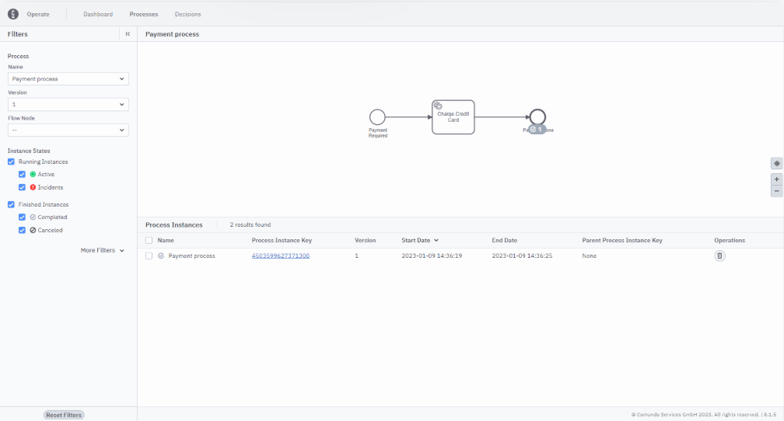

Job Handled
Congratulations! You have now created a Job Worker that has completed the Charge Credit Card task by invoking an external service.

Start Process with Variables (Modeler)
To continue building out our example, we will need to provide a Payment Request to the Payment Process so that we can pass it to the Credit Card Service.
Process Variables
Process Variables are part of a Process Instance. Variables can be passed in at the start of a process and can be accessed and modified during the execution of a process. Variables can also be accessed and modified by a Job Worker.
You can find more information here.

Start Process with Variables (Modeler)
You can use the Desktop Modeler to start a Process Instance with a Payment Request by following the steps below.
Payment Request
For the purposes of this course we will define a Payment Request as follows:
- reference (String) - A unique Payment Reference
- amount (Double) - The Payment Amount
- cardNumber (String) - The 16-digit Card Number
- cardExpiry (String) - The Card Expiry Date MM/YYYY
- cardCVC (String) - The Card Security Number
- Ensure that the PaymentApplication is not running.
- Select the Start Current Diagram button in the Status Bar of the Modeler
- This will open a Start Process Instance dialog box
- Enter the following JSON into the Variables field and then click on the Start button
{
"reference": "C8_12345",
"amount": 100.00,
"cardNumber": "1234567812345678",
"cardExpiry": "12/2023",
"cardCVC": "123"
}

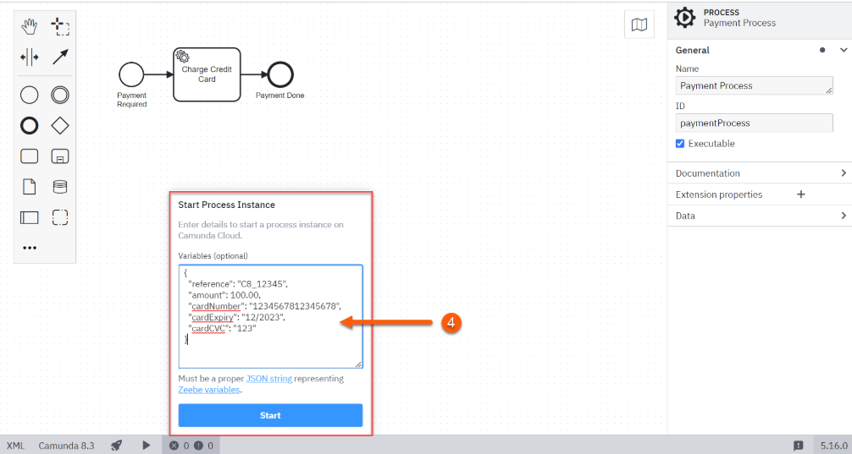

- You should get a Process instance started message.
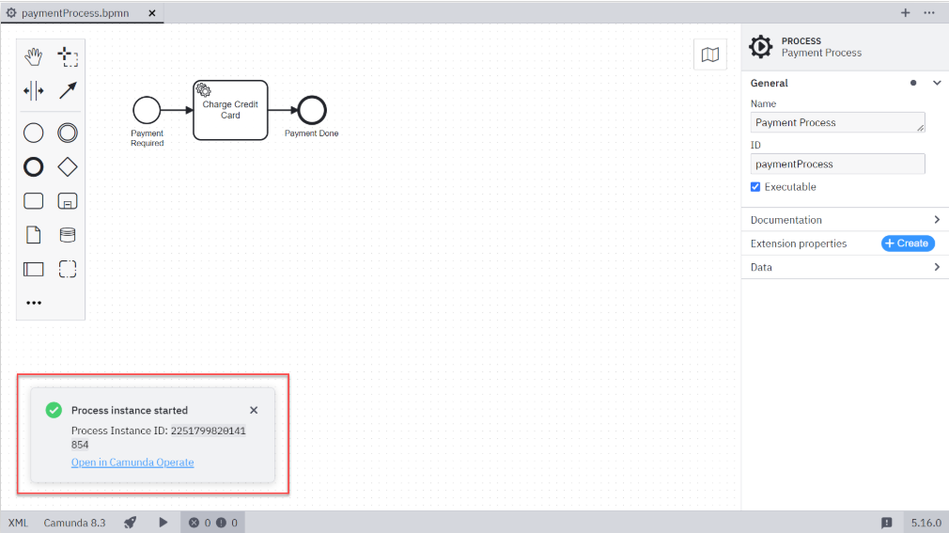

View Process Instances
We can now view the process instance in Operate by following the steps below:
- Launch Operate by following the steps in the previous lesson. Alternatively, refresh the window if you still have Operate open.
- Click on Payment Process from the Instances by Process panel on the left-hand side of the screen
- Operate will now show a running instance of our Payment Process along with the variables representing our Payment Request. The completion of the Charge Credit Card Service Task is still pending; you can see this from the presence of the green marker against the Service Task.
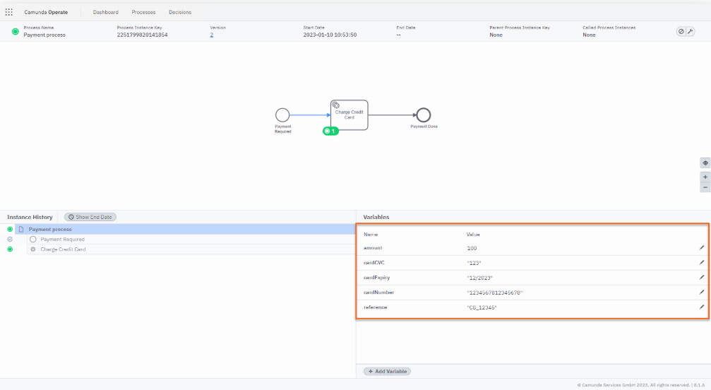

Started a Process Instance
Congratulations! You have now started an instance of the Payment Process with a Payment Request using the Desktop Modeler.

Start Process with Variables (Client)
Starting process instances using the Desktop Modeler is useful for testing purposes but in the real world it is much more useful to start a process instance programmatically.

Start Process with Variables (Client)
We can use the existing PaymentApplication to start a Process Instance with a Payment Request by following the steps below.
Multiple Applications
For the purposes of simplicity in this course, we will add all client functionality into a single Java PaymentApplication. However, in a real world implementation, it is much more likely that this functionality would be distributed across multiple applications and potentially implemented using different languages / frameworks.
- Ensure that the PaymentApplication is not running
- Create a Map of the Process Variables that will be used to start the Process Instance by adding the following snippet to the main method above the registration of client.newWorker i.e. the first statement of the try block:

final Map<String, Object> variables = new HashMap<String, Object>();
variables.put("reference", "C8_12345");
variables.put("amount", Double.valueOf(100.00));
variables.put("cardNumber", "1234567812345678");
variables.put("cardExpiry", "12/2023");
variables.put("cardCVC", "123");

- Add a new Create Instance Command beneath the map of process variables
client.newCreateInstanceCommand()
.bpmnProcessId("paymentProcess")
.latestVersion()
.variables(variables)
.send()
.join();
Create Instance Command
The Create Instance Command command creates and starts an instance of the specified process. The process definition used to create the instance can be specified either using its unique key (as returned by DeployProcess), or using the BPMN process ID and a version. You can read more here.

Run the Application
We can run our updated PaymentApplication. This will create a new Process Instance and will then launch a Job Worker which will complete the Charge Credit Card task and subsequently the process.
If you now run the PaymentApplication from your IDE or Maven, you should see output similar to the below:
Charging Credit Card

View Process Instances
We can now view the process instance in Operate by following the steps below:
- Launch Operate by following the steps in the previous lesson. Alternatively, refresh the window if you still have Operate open
- Click on Payment Process from the Instances by Process panel on the left-hand side of the screen
- Operate will now show a completed instance of our Payment Process along with the variables representing our Payment Request. The Charge Credit Card Service Task is now complete; you can see this from the presence of the grey marker against the End Event
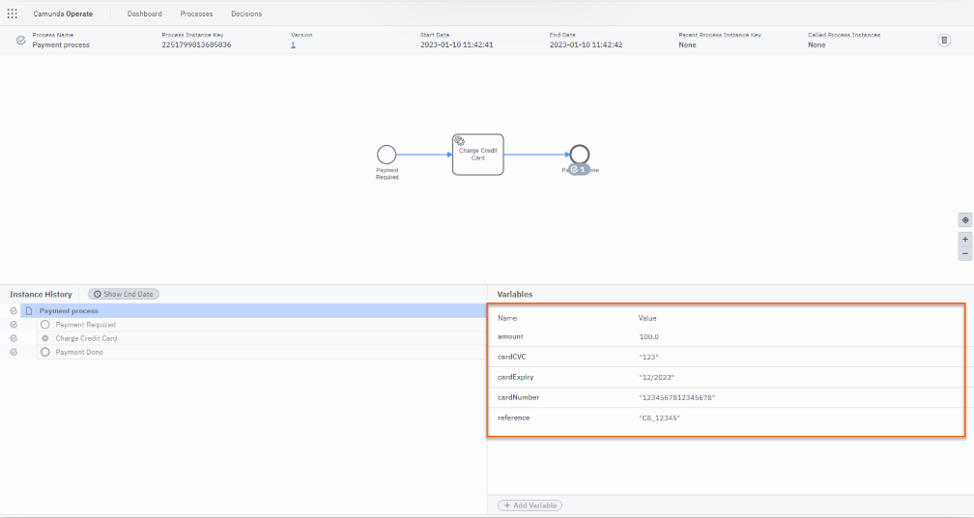

Started a Process Instance
Congratulations! You have now started an instance of the Payment Process with a Payment Request using the Java Client.

Handle Data in the Job Worker
We can now pass a Payment Request into the Payment Process using either the Desktop Modeler or a Client. Next, we need to update our Job Worker to retrieve the process variables and modify them accordingly after the job has been completed.

Update the Credit Card Service
We will start by updating the Credit Card Service which is invoked from the Payment Process. The CreditCardService will now accept the PaymentRequest that was passed in at the start of the process and return a confirmation number.
- Open the CreditCardService in the com.camunda.academy.service package
- Modify the chargeCreditCard method to CreditCardService to accept the parameters representing the PaymentRequest
- Log the PaymentRequest that is passed and return a confirmation number
public class CreditCardService {

public String chargeCreditCard(final String reference,
final Double amount,
final String cardNumber,
final String cardExpiryDate,
final String cardCVC) {

System.out.println("Starting Transaction: " + reference);
System.out.println("Card Number: " + cardNumber);
System.out.println("Card Expiry Date: " + cardExpiryDate);
System.out.println("Card CVC: " + cardCVC);
System.out.println("Amount: " + amount);

final String confirmation = String.valueOf(System.currentTimeMillis());
System.out.println("Successful Transaction: " + confirmation);
return confirmation;
}
}

Update the Credit Card Service Handler
We will now need to update the Handler that will invoke the CreditCardService each time a Process Instance reaches a Service Task with the type of chargeCreditCard.
This CreditCardServiceHandler will now pass the Process Variables into the CreditCardService and will return the confirmation number from the service into the Process Instance.
- Open the CreditCardServiceHandler in the com.camunda.academy.handler package
- Obtain a list of Process Variables from the Job with the following snippet
final Map<String, Object> inputVariables = job.getVariablesAsMap();
final String reference = (String) inputVariables.get("reference");
final Double amount = (Double) inputVariables.get("amount");
final String cardNumber = (String) inputVariables.get("cardNumber");
final String cardExpiry = (String) inputVariables.get("cardExpiry");
final String cardCVC = (String) inputVariables.get("cardCVC");

- Modify the chargeCreditCard method invocation to accept the parameters representing the PaymentRequest and return the confirmation number

final String confirmation =
creditCardService.chargeCreditCard(reference, amount, cardNumber, cardExpiry, cardCVC);

- Create a Map of the Process Variables that will be returned to the Process Instance

final Map<String, Object> outputVariables = new HashMap<String, Object>();
outputVariables.put("confirmation", confirmation);

- Modify the Complete Command to also return the confirmation number from the Credit Card Service
client.newCompleteCommand(job.getKey()).variables(outputVariables).send().join();

- The Handler should now look similar to the following:
public class CreditCardServiceHandler implements JobHandler {

CreditCardService creditCardService = new CreditCardService();

@Override
public void handle(JobClient client, ActivatedJob job) throws Exception {

final Map<String, Object> inputVariables = job.getVariablesAsMap();
final String reference = (String) inputVariables.get("reference");
final Double amount = (Double) inputVariables.get("amount");
final String cardNumber = (String) inputVariables.get("cardNumber");
final String cardExpiry = (String) inputVariables.get("cardExpiry");
final String cardCVC = (String) inputVariables.get("cardCVC");

final String confirmation = creditCardService.chargeCreditCard(reference, amount, cardNumber, cardExpiry, cardCVC);

final Map<String, Object> outputVariables = new HashMap<String, Object>();
outputVariables.put("confirmation", confirmation);

client.newCompleteCommand(job.getKey()).variables(outputVariables).send().join();
}
}

Run the Application
If you now run the PaymentApplication from your IDE or Maven, you should see output similar to the below:
Starting Transaction: C8_12345
Card Number: 1234567812345678
Card Expiry Date: 12/2023
Card CVC: 123
Amount: 100.0
Successful Transaction: 1673360720543

View Process Instances
Finally, view the process instance in Operate by following the steps below:
- Launch Operate by following the steps in the previous lesson. Alternatively, refresh the window if you still have Operate open.
- Click on Payment Process from the Instances by Process panel on the left-hand side of the screen
- Operate will now show a completed instance of our Payment Process along with the variables representing our Payment Request. The Charge Credit Card Service Task is now complete; you can see this from the presence of the grey marker against the End Event.
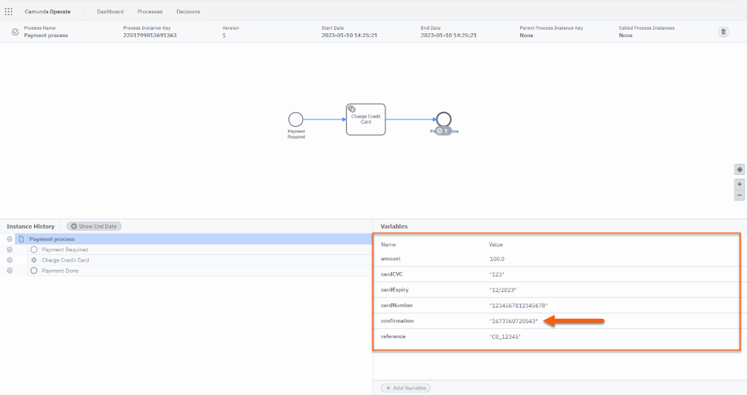

Started a Process Instance
Congratulations! You have now started an instance of the Payment Process that passes Process Variables to and from a Job Worker.

Cleanup Environment

Overview
We have now met all of the business requirements that have been defined in our Scenario. We are now in a position where we can perform an end-to-end test of our process to ensure that everything is working as expected.
However, as we have been testing our process definition as we have been developing it, it is likely that we have several incomplete process instances still running. Having incomplete (and possibly incorrect) process instances running in our environment may make it more difficult to confirm that everything is working as expected in an end-to-end test.
We will now Cancel and Delete any remaining instances so that we have a completely clean environment in which we can conduct our acceptance tests.

Cancel & Delete Process Instances

Launch Operate
Launch Operate by following the steps below:
- From the Console, select Clusters
- Select Camundanzia from the Clusters page
- Click the Launch link next to Operate in the Cluster Details page
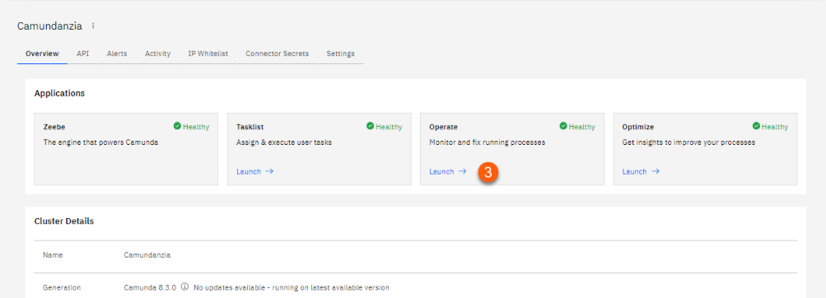

- After a few seconds, the Operate Dashboard will be displayed

Cancel Process Instances
We can now Cancel the process instances in Operate by following the steps below:
- Click on Payment Process from the Instances by Process panel on the left-hand side of the screen
- On the bottom left of the screen is a series of filters that will allow you to select Running or Finished process instances
- Ensure that the Running filters are selected and the Finished filters are not selected
- Then, for each Process Instance that is shown in the Instances panel, click the Cancel Instance button to the right-hand side of the process
No Running Processes
This section can be skipped if there are no running processes shown in the Instances panel.

- The Process Instance will then be cancelled and will disappear from the Instances panel
What happened to the Process Instance?
When you Cancel a process in Operate it changes to a stopped state. As the process is no longer running it is not picked up by Running filter.
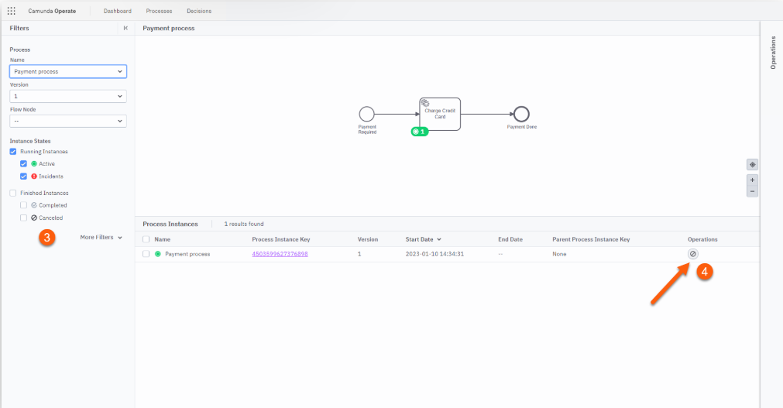

Delete Process Instances
We can now Delete the finished process instances in Operate by following the steps below:
- On the bottom left of the screen is a series of filters that will allow you to select Running or Finished process instances
- Ensure that the Finished filters are selected and the Running filters are not selected
- Then, for each Process Instance that is shown in the Instances panel, click the Delete Instance button to the right-hand side of the process
- The Process Instance will then be deleted and will disappear from the Instances panel
What happened to the Process Instance?
When you Delete a process in Operate it is completely removed from the Zeebe Engine.
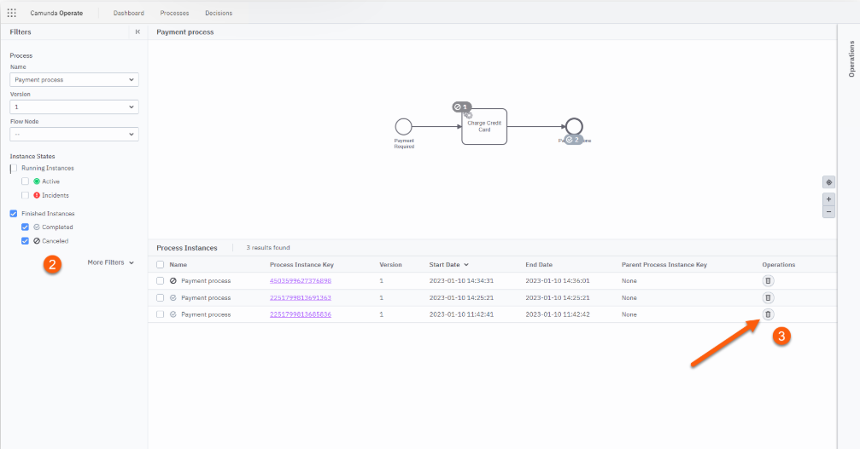

Cleaned the Environment
Congratulations! You have now removed all instances of Payment Process from the environment.

Test Application
We are now ready to test the Payment Process.

Review Acceptance Criteria
Let's start by reviewing the acceptance criteria that was defined earlier; we need to ensure that all of the requirements below can be met by our process.
- Partner orders are processed using the Payment Process
- The Payment Process requires a Payment Request which includes the Reference, Amount and Credit Card Details
- The Payment Process processes orders automatically using a Credit Card Service, i.e. without human intervention

Test Application
We can test our application and confirm that the acceptance criteria above has been met by launching a single process instance.

Run the Application
Running the final version of our PaymentApplication will ...
- Create a new Process Instance
- Register a Job Worker for the chargeCreditCard task type
- Pass the PaymentRequest Process Variables into the Job Worker
- Invoke the 'CreditCardService'
- Return the Confirmation as a Process Variable
- Complete the Charge Credit Card task
If you now run the PaymentApplication from your IDE or Maven, you should see output similar to the below:
Starting Transaction: C8_12345
Card Number: 1234567812345678
Card Expiry Date: 12/2023
Card CVC: 123
Amount: 100.0
Successful Transaction: 1673360720543

View Process Instances
View the process instance in Operate by following the steps below:
- Launch Operate by following the steps in the previous lesson. Alternatively, refresh the window if you still have Operate open.
- Click on Payment Process from the Instances by Process panel on the left-hand side of the screen
- Operate will now show a completed instance of our Payment Process along with the variables representing our Payment Request. The Charge Credit Card Service Task is now complete; you can see this from the presence of the grey marker against the End Event.
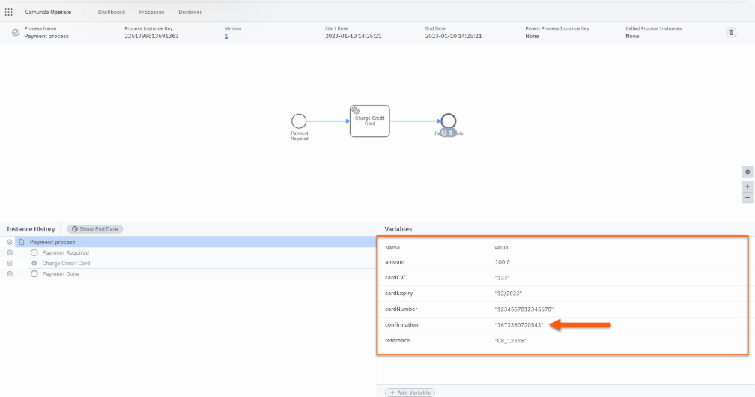

Success
Congratulations! You have now completed the testing of your process and have confirmed that it meets the acceptance criteria defined at the start of this course.

Example Solution

Solution
If you encountered any problems during this course or were unable to complete the process configuration, you can compare your solution with our example solution below.

GitHub Repository
Our version of the application (Process Definition & Job Worker) can be found in the GitHub Repository below:
- Solution - Payment Application

Process Diagram
Our version of the Process Diagram can be found below:


